**Assignment No. 02**

**Q.1. Give the problem statement of your project.**

**Ans.**

**Project Problem Statement**

**(Smart Mall Shopping)**

**Project description:**

The purpose of “Smart mall Shopping” project is to provide most user friendly android application to customer through which they can easily purchase the goods with high quantity. With the help of this android application user can select the products, check the products details like price, expiry date, manufacturing date etc., select the product quantity, total amount of shopping etc. When customer submit their shopping list to shop keeper then they can give products to customer.

Before doing all this things customer need to login into system and select the particular mall or shop in which they want shopping the products. Using this app user can also update their product list. If customer want to remove or add some products from list then they can do this.

**Existing System:**

In existing system customer need to carry trolley or bucket to store the products. Sometimes it creates the problem because when customer have huge quantity of product then they cannot carry this product during all shopping. Therefore, develop the android app through which customer only need to carry mobile (android app) via this they can select the product and submit the list to shop keeper.

**Modules of Project:**

There are some modules through which this application can work.

1. **Registration:** Admin and customer need to provide some details to system. Admin need to give their employee id and name as well as customer need to provide their name, contact details, address etc.
2. **Login:** When admin and customer register into system then system provide some is and password to them.
3. **Admin:** Admin can add new products into list or if any product is not available in shop then they can remove this product from list. Admin can update the product price.
4. **Customer**: Customer can able to select the products from list and also possible to select the product quantity according to their need.

**Software requirements:**

Developing for “Smart mall Shopping” includes the following requirements:

* The Android SDK.
* Apache, an open source tool that automates aspects of the Android build process.

**Q.2. Use case diagram of your project.**

Smart Mall Shopping

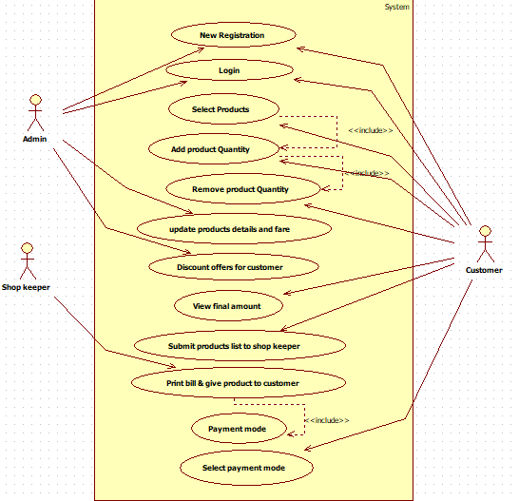

**Q.3. Write use-case specification document for all use-case in your project.**

**Ans.**

* Use-case name: Smart Mall Shopping
* Brief Description: Customers can purchase the products according to their quantity using “Smart mall shopping” android application.
* Actors involved:

1. Admin
2. Customer
3. Shop keeper

* Frequency of usage or priority: Medium
* Pre-Condition: Admin and customer must have login into system.
* Basic Flow:

Admin:

|  |  |
| --- | --- |
| Actor | System |
| 1.Admin hits Registration action |  |
|  | 2.display registration form |
| 3.Provide important details and complete registration process. |  |
|  | 4.Give the access to login into system. |
| 5.Admin hits update action |  |
|  | 6.Update product details. |
| 7.Admin hits offer actions. |  |
|  | 8.List of offers like festival offer, season offer, special customer offer etc. |
| 9.Admin hits logout action. |  |
|  | 10. Remove out from system or show home page. |

Customer:

|  |  |
| --- | --- |
| Actor | System |
| 1.Customer hits Registration action. |  |
|  | 2.Display registration form. |
| 3. Provide important details and complete registration process. |  |
|  | 4. Give the access to login into system. |
| 5.Customer hits search action. |  |
|  | 5.Display products list. |
| 6.Update products from list. |  |
|  | 7.System update list according to actor action. |
| 8.Customer hits total amount. |  |
|  | 9.System display amount details |
| 10.Actor hits submit action . |  |
|  | 11. Print the bill and give customer products via shop keeper. |
|  | 12.System display the payment mode. |
| 13.Select payment mode and complete the transaction |  |
|  | 14.System display message “Successful, please use again.” |
| 15.Hits logout action. |  |
|  | 16.Get out from system or display home page. |

Shop keeper:

|  |  |
| --- | --- |
| Actor | System |
| 1.Shop keeper hits registration action. |  |
|  | 2.System display registration form. |
| 3.Provide important details and complete registration process. |  |
|  | 4. Give the access to login into system. |
| 5.Acotr receive notification, click on that notification. |  |
|  | 6.System display customer shopping list. |
| 7.Check products names and product quantity and collect products according to that list and hits OK action |  |
|  | 8.System print the bill and receive payment from customer. |

* Alternet Flow of event:

Admin:

|  |  |
| --- | --- |
| Actor | System |
| 5.Actor hits update action. |  |
|  | 6.1.If product is not available into shop then remove it from product list. |
|  | 6.2.If new product produce into market then add it into product list. |
|  | 6.3.Update product cost according to market cost. |

Customer:

|  |  |
| --- | --- |
| Actor | System |
| 6.1.Add new product into list if they want |  |
| 6.2.Remove product from list if they don’t want. |  |
| 6.3.Increase product quantity. |  |
| 6.4.Decrease product quantity. |  |
|  | 7.1. System update customer list and generate error message if product exp. Date is near or cross. |
|  | 7.2.System display error message if customer quantity size is out of stock. |

Shop keeper:

|  |  |
| --- | --- |
| Actor | System |
|  | 6.1.Display error message if quantity=0 |
|  | 7.1.Display error message if payment is not done within 20mins. |

* Post Condition: Selected product is available into shop.
* Special condition (non-functional requirement): System should be response within 5 Sec.